«Display_Name»
Using Blender 2.7 for Animation - Advanced 4 - Lighting & Rendering: Lighting Theory, 3-Point Lighting, & Shading

GOAL: Create 4 Images using 4 different types of lighting (Using 3 Existing Scenes plus 1 specially-lit scene created in this part)
BONUS: Make video containing 4 different lighting setups on pages 7.1-7.4 (see Bonus requirements on last page)
- Create a new scene or use an existing scene
- File, Save As, 3dv4-1 threepoint
Lighting Theory
Lighting Theory is the study of standard ways to light a scene to show all objects well and to control shadows, in a way that matches the kind of scene you want to make. There are many way to light a scene, & you can use your existing scenes.

Three Point Lighting (pick one of your existing files for this, one that can have shadows from multiple lights such as an indoor scene)
Three point lighting is often used by photographers and filmmakers, and is the basic starting point for learning lighting. To create more lamps, click Add, Lamp, Point. The basic lights used in 3-point lighting are:
- Key Light: Brightest, on one or the other side of the camera
- Perspective (or Fill) Light: on opposite side of camera as Key Light but not as bright. Shows parts of the subject that couldn’t be seen by just one light.
- Backlight: Behind and slightly above the subject. This creates a sharp bright outline around the subject, making the subject stand out from the background
You can be creative with lighting, but it is good to know this basic technique so that if something doesn’t look right you know what kind of light may need to be added. The human eye is able to compensate for different lighting because of its ability to accurately change sensitivity and see in 3D, but pictures from cameras and 3D rendering often need more kinds of light in order to make the subject more visible and also bring out the shape of the subject, much like a real camera—it sees exactly what you give it without compensating.

Try 3-point lighting on one of your existing scenes:
Make sure the camera is positioned so that it presents the object well (put cursor over 3D View, hit 0 on numpad, then View, Properties, then check “Lock Camera to View” to make camera move: click&drag the scroll wheel to rotate, or scroll the scroll wheel to zoom. You can also click an object then click ‘.’ dot on the numpad to center on an object. When you are done, uncheck “Lock Camera To View” so camera stays in that place next time you move your view to work on your scene.)

To make your scene ready to render as a quality image, you must first:
Set Smooth or Smooth with Edge Split where needed (instructions below)
You might be wondering why your object has facets (flat shading). You can change this:
In Object Mode, on the Tool Shelf on the left (if it is not visible click “View”, “Tool Shelf” to show or hide it), and click “Smooth”
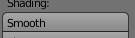
This makes ALL of the edges smooth but this is usually not what you want.
Select an object that should have some sharp edges but not all (such as a mountain or cylinder) click Smooth, then:
Next click “Modifiers” 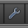 button.
Click “Add”, “Edge Split”
You can also set at which angle the edges become sharp.
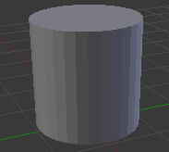  Flat | 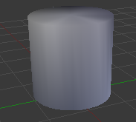  Smooth | 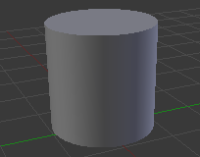  Smooth  with Edge Split

Whenever you are finished,
Click “File”, “Save”, “Render”, “Render Image”, “Image”, “Save As Image”, click your home drive (H:), in 2nd box name it lighting1 three-point
Using Blender 2.7 for Animation – Advanced 4.2 - Lighting & Rendering: Radiosity

Radiosity (create a new file for this one)
File, Save As, 3dv4-2 radiosity
Radiosity is an effect where light bounces off of one object and shines colored light on another object. For example, if a white ball is sitting on a blue table in the sunlight, the bottom of the ball will look slightly blue while it is on the table, especially the bottom of the ball that does not have direct sunlight on it. Many 3D modeling programs have Radiosity built in, but for games and other situations where you may need real-time interactivity or fast rendering (as opposed to many minutes per frame), to you may also fake Radiosity. To start out, make a table using a flattened cube, make it blue, then put a sphere on top of it:
- Create a lamp below the object (Add, Lamp, Point):
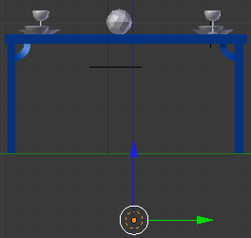
- Turn off shadows for the lamp so that the table doesn’t block it:
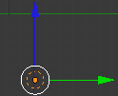  Right-click to select the lamp | 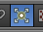  Click the Object Data button | 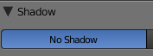  Click “No Shadow”
- Still in the Object Data button menu, click the color swatch 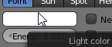 to change it to the color of the table.
Example using three point lighting (notice brown light hitting the white objects)…
with brown hemi lamp under it simulating radiosity:  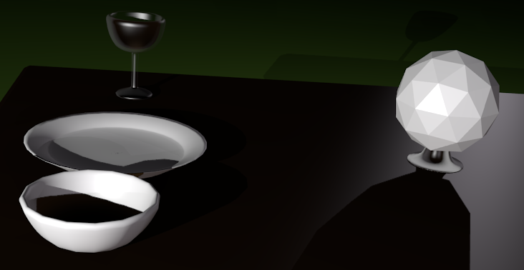 | & after moving lights higher to reduce shadows:  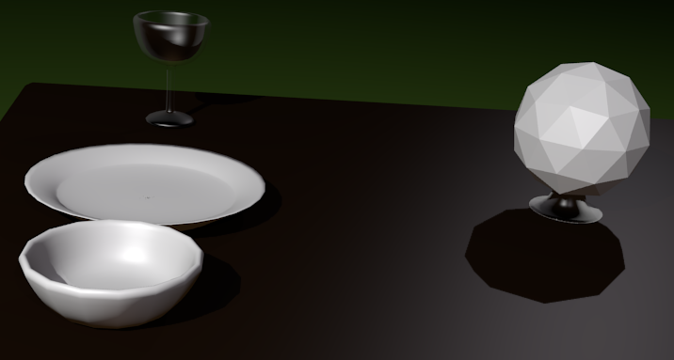

Set Smooth or Smooth with Edge Split where needed (see instructions on Activity 7.1)
Click “File”, “Save”, “Render”, “Render Image”, “Image”, “Save As Image”, click your home drive (H:), in 2nd box name it lighting2 radiosity
«Display_Name»
Using Blender 2.7 for Animation – Advanced 4.3 - Lighting & Rendering: Global Illumination

Global Illumination (pick an outdoor scene, one that can have little to know shadows such as an overcast day or underwater)
Global Illumination (GI) is an effect that simulates radiosity and atmospheric light by creating a sphere of light around the scene. The sphere of light can be a solid color, or an image. If it is an image, this is called Image-Based Lighting (IBL) which can more accurately simulate both radiosity and atmospheric light, because the image can be the color and brightness of all parts of the ground on the bottom and color and brightness of the all parts of the sky, including the sun if needed, on the top. Then the image is wrapped around a sphere and radiates toward the scene as if there were hundreds or thousands of tiny colored lights (which is exactly how most programs do Global Illumination and Image-Based Lighting). These tiny colored lights that can be invisibly simulated by GI and IBL can also be shadowed lights with radiosity to create an even more realistic effect. This quantity of shadow and radiosity calculation can take each frame many hours (or minutes using a render farm of many computers working together).

You can use the Environmental Light option to simulate GI and IBL:
- File, Open, then choose an outdoor scene such as “Paint” or “outdoor scenic tour” or “city scene”
  - File, Save As, 3dv4-3 gi
- Delete all lamps
- Click the “World” button
  - Change the Horizon color to be the color of the environment (such as blue for underwater or bluish white for sky)
  - Check the “Environment Lighting” option
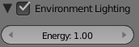
  - Change color from “White” to “Sky color” (or “Use background color” for previous versions of Blender)
  - Try that out with Render, Render Image. When it looks good,
Set Smooth or Smooth with Edge Split where needed (see instructions on Activiy 7.1)
Click “File”, “Save”, “Render”, “Render Image”, “Image”, “Save As Image”, click your home drive (H:), in 2nd box name it lighting3 global.

Tips
You can mark certain edges to always be sharp regardless of Edge Split’s “Edge Angle”:
In Edit Mode, click “Edge select mode”
Right-click to select the edge you want to stay sharp.
(click “Select”, “Edge Loop” or “Select”, “Similar”, “Length” to select more edges like it if needed)
Then click “Edges”, “Mark Sharp”.
As long as you have Smooth turned on AND an Edge Split modifier, the Mark Sharp edges will stay sharp. To unmark them as sharp, go to edit mode, select the edge, then check the “Clear” box on the Tool Shelf on the left under Mark Sharp (if no longer have the Mark Sharp box open, click “Mesh”, “Edges”, “Clear Sharp” instead—this will check the “Clear” checkbox under Mark Sharp automatically).

Fix render issue where scene is completely black:
If everything is black no matter what you do, the properties of the rendering layer may have been changed. Click Render button. Expand “Layer” section. If there are more layers listed below the first “RenderLayer” you may delete them if you are not using them. This will not delete objects—these are only rendering layers. Then select first RenderLayer (usually called “RenderLayer”) then set as follows:
Make sure the first layer is selected (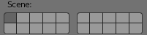) and make sure ONLY the following are checked:
- Checkboxes for “Include”: Solid, Halo, ZTransp, Sky, Edge, Strand
- Checkboxes for “Passes”: Combined, Z
- Checkboxes for Shading: Textures, Shadows, Subsurface Scattering, Environment Map, Ray Tracing, Color Management
(Checkboxes in the following sections don’t affect the problem: Anti-Aliasing, Performance, Post Processing, Stamp, Bake, Full Sample Motion Bar)

Using Blender 2.7 for Animation – Advanced 4.4 - Lighting & Rendering: Ambient Occlusion & 7.1-7.4 Project

Ambient Occlusion (pick an outdoor scene for this one where there can be soft shadows)
- Open any outdoor scene other than the one you used for 7.3
- File, Save As, 3dv4-4 ambient
Ambient Occlusion describes how shadows gradually become darker as they are “deeper” in the shadowed area. This option will help the lighting in your scene look more realistic.
- Click the “World” button
- In the world button tab, check the “Ambient Occlusion” 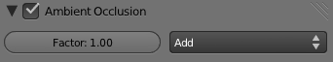 checkbox

With this more accurate simulation of light, even a single light can illuminate the scene (even with Environment Lighting turned off).
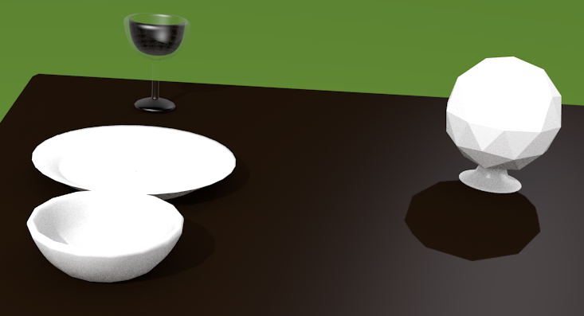  Factor 1.00 and “Add” mode,  The scene looks rather bright but looks like a realistic outdoor scene. | 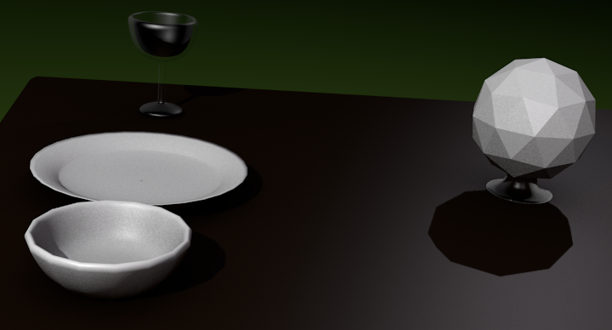  - Click “Add” then choose “Multiply” for more contrast, such as for simulating lowlight situations.  - Also, “Factor” can be changed for fine tuning brightness. | 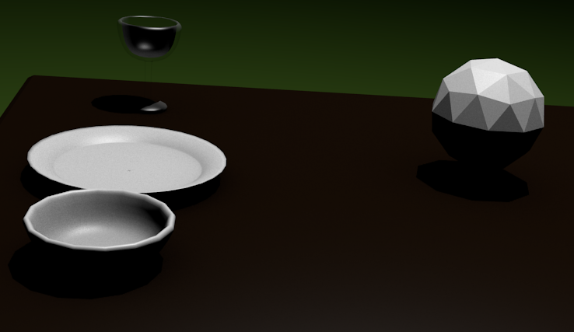  Using only one light still looks fairly realistic when using Ambient Occlusion (this example uses “Add” mode and Factor 1.00)
After you have the lights placed above the scene and the camera showing the scene well,
Set Smooth or Smooth with Edge Split where needed (see instructions on activity 7.1)
Click “File”, “Save”, “Render”, “Render Image”, “Image”, “Save As Image”, click H:, in 2nd box name it lighting4 Ambient Occlusion

Lighting & Rendering Project: Requirements for All 4 Images (7.1-7.4)

Create Images for 4 of your projects, using lighting and camera:
- You must follow the instructions on pages 7.1 to 7.4 to light & render 4 scenes with a good camera position, using each of the 4 techniques. Tips are optional. You can either use previous projects, or any other scene as long as there are:

4 total images Saved (Render, Render Image, then at bottom click “image”, Save Image)

One image for each technique (each from a separate scene)
- Use good lighting to show the object well and add realism
- Use a good camera angle to create good images of your scenes
- You must use Smooth shading on all objects that are supposed to be smooth to make the images look like what you intended
- You must use Edge Split on all Smooth objects that are supposed to have sharp edges to make the images look like what you intended
- You must save each image after you render—after you click File, Save, you must still also save a separate png file which is a regular image file that someone without blender can open: click “Render”, “Render Image”, “Image”, “Save As Image”

BONUS: Combine all 4 projects (one being 7.2 table), all meeting the requirements above, into one scene file (do not use Global Illumination, but instead use one of the other lighting setups)—to do that, click File, Append, single-click project file, single-click Objects category, hit ‘a’ or draw box to select all parts you want (don’t need camera—you can shift-click to deselect), Append/Link. Blender will automatically select what you imported—now, while the imported objects are still selected, you should press ‘g’ on keyboard to move it where you want it (if you accidentally select something else, Ctrl Z to undo)—next, while the imported objects are still selected, press ‘s’ to scale them so they match the scene. Then create one big animation that has all 4 projects, changed to meet the requirements at the top of this page. You must spend at least one second on each of the 4 projects and camera must move to each project. As usual, in Render button tab you must choose a video filename: click browse button shown below,
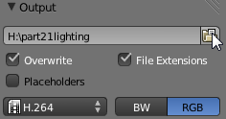 then click H: then in the second box name it lighting bonus, then click Accept,
& choose H.264 (see picture above) before you click Render, Render Animation.

